**MKTG 8604**

**New Frontiers in Retailing: Magic and Logic**

**The Digital Wallet goes Shopping - Blockchain Authentication of Luxury Goods**

Whitney Andrews

Lena Belling

Laura Brown

Vaiyshnav Gunapati

Jun Oh

May 2022

**Columbia Business School**

Advised by: Prof. Oliver Chen and Prof. Kinshuk Jerath

The Digital Wallet goes Shopping - Blockchain Authentication of Luxury Goods

| Hypotheses | * Blockchain technology will become the standard of luxury good authentication for new goods * Implementation of digital IDs through blockchain will transform the secondary luxury market * Digital IDs will proliferate fashion and e-commerce and brands that don't embrace will fall behind |
| --- | --- |

| Supporting Arguments | * Transaction information between the two parties can be stored in transparent, verifiable and permanent way * Frictionless authentication & royalties for brands through resale * More consumers are now expecting greater transparency from the brands with which they purchase from |
| --- | --- |

| Challenges | * Fragmented Solution Space * Cost of Minting * Environmental Impact |
| --- | --- |

**Executive Summary**

Counterfeits are a battle that luxury retailers have been fighting for long - the total trade in counterfeit goods is estimated to be $4.5 trillion annually, with luxury goods accounting for 60% to 70% of the total.   
Throughout the past years, blockchain technology has caught traction in the public eye to be a solution to this, with significant investment flowing into blockchain infrastructure being built. As a digital unique identifier that is difficult to hack or imitate, blockchain became a game changer to provide a key opportunity for luxury retailers to authenticate their products sold, providing customers with a digital and personalized proof, which can be passed on to next owners of the product.  
  
The way information is recorded and stored is what makes this technology special - information stored in chronological order and the data is immutable, which means that information cannot be erased or edited, and key players in the luxury market, such as LVMH, Prada and Cartier already have begun to engage with this technology to create transparency and trust for all customers and stakeholders.As blockchain technology becomes the new standard of luxury good authentication for new goods, the secondary luxury market, which is valued over $37B, will encounter a transformation. Leveraging digital IDs on the blockchain, consumers can experience frictionless authentication processes, seamlessly validating authenticity, provenance, and other important information for second-hand purchase.

Furthermore, as this trend becomes more prevalent, e-commerce platforms and brands that don't embrace this technology will fall behind as more consumers are now expecting greater transparency from the brands with which they purchase from.

Looking forward, three critical and yet unanswered questions remains for the technology’s prevalence - 1) would it be possible to integrate and create a common standard among brands, 2) would brands willing cut its profit margin by paying the cost of minting and 3) would the brands able to find a balance between digital innovation and their potentially negative impact to the environment

**Introduction**

A standardized method to authenticate luxury goods is imminent. As per a Harvard Business Review, the total trade in counterfeit goods is estimated to be $4.5 trillion annually, with luxury goods accounting for 60% to 70% of that.  
The first tangible movement in the direction of leveraging and promoting blockchain technology to counter the rising tide of counterfeit goods happened in April 2021. Three major luxury players - LVMH, Prada and Cartier - joined forces in creating the so-called “Aura Blockchain Consortium”, which aims to provide each individual product with a digital ledger.   
Within this ledger, the history of the product including sales date, potential repairs and resells are documented alongside sourcing and sustainability information on the original manufacturing of the product - storing decentralized information using a multi-nodal private blockchain technology, ensuring that information cannot be erased, edited or copied[1].

**Hypothesis I**

Blockchain technology has the capability of transforming the way we live and conduct business. Widely known in the financial sector as the underlying technology behind crypto currencies, blockchain has a vast range of applications beyond finance. What makes this technology special is the way information is recorded and stored. Information is stored in chronological order and the data is immutable, which means that information cannot be erased or edited. Key players in the luxury market have begun to engage with this technology in various forms, and this is just the beginning. As companies like LVMH, Prada, Vacheron Constantin and Alexander McQueen begin to adopt this technology and push forth the frontier in the luxury section, a wave of transformation will usher in a new era for luxury authentication. Digital IDs will become the standard of authentication for new luxury goods.

Authentication, especially for luxury accessories and jewelry has always been a priority in the industry. Many years ago, luxury jeweler and watchmaker Cartier implemented an analog system of assigning a serial number to each creation as a means of authenticating and tracking. Cartier maintains control and security of this process by limiting access to their database to only Cartier employees. But the process is imperfect and does not prevent secondary market retailers from asserting their ability to authenticate their products.

Luxury watchmaker Vacheron Constantin was an early adopter in the space, rolling out a collection of watches with digital certifications in 2019. The success of the initiative prompted Constantin to create a community for clients that enable authentication of their timepieces through their lifetime, extending to all of its timepieces. Not only does this program strengthen the relationship Constantin has with its clients, but it also reinforces the value of their timepieces, and positions them ahead of watchmakers who do not offer the same service. Aside from authenticity, the blockchain technology is able to store complete information about the timepiece, such as technical information, product history and certifications. As more luxury watchmakers are able to adopt and offer this technology, those who cannot implement it will lose value.

The most telling wave of adoption comes from the firm EON. EON is partnering with premier luxury retailers such as Net-a-Porter, to roll out ecosystems of digital IDs, digitizing billions of products for retailers. The differentiation between a brand adopting digital IDs in an ecosystem of identification, versus a vacuum, is that it creates a common standard across brands and retailers. As this first standardized language becomes more widely adopted, the network effects will propel more brands to join in this new frontier.

**Hypothesis II**

The implementation of digital IDs through blockchain will transform the secondary luxury market. Digitals IDs will enable customers to seamlessly validate authenticity, provenance, and other unique item information. This mechanism has the ability to revolutionize the re-commerce and resale markets for luxury goods.

Currently, a section of customers transact through platforms like The RealReal or StockX, to take advantage of their extensive authentication methodologies, while others transact through platforms like eBay apprehensively without authentication. The use of digital IDs on the blockchain can make authentication frictionless, where anyone can validate goods seamlessly. The second-hand luxury market is valued at $37B+, and a large part of the friction associated with this market is authentication. Digital IDs provide a seamless way to authenticate instantly. Resale marketplaces can save significant operational expenses with instant authentication, whereas trusted peer-to-peer sales powered by Digital IDs can create new transformative business models. Digital IDs can be the underlying infrastructure that powers the resale market for luxury goods.

Digital IDs will enable creators to monetize their offerings beyond just the first sale. It can keep track of the lifecycle of the goods across owners and enable brands or creators to earn recurring revenue as customers transact on their products during their lifetime. Like NFTs, where creators get paid royalties ranging from 5%-10%, brands with physical goods can similarly get recurring royalties with Digital IDs. This can revolutionize the brand's role in the second-hand market, engaging with customers like never before while opening new revenue streams and business models.

**Hypothesis III**

Digital IDs will proliferate fashion and e-commerce, and brands that don't embrace this technology will fall behind. The rise of new technologies coupled with the public’s growing awareness of the fashion industry’s contribution to global warming is causing significant, large-scale changes in consumer behavior, and the fashion industry itself. Consumers are now expecting greater transparency from the brands with which they purchase from. Digital IDs have emerged in response to new consumer expectations as an easy way for brands to convey the environmental impact of the items they purchase. Additionally, this increased consumer selectivity and the criticism of the fashion industry’s environmental impact has placed pressure on brands to sustainability innovate across design, manufacturing and supply chain processes. Digital ID’s and the use of Blockchain technology will allow for end-to-end product traceability and visibility of the garments carbon footprint.

Firstly, the fight against climate change is becoming front and center in many political agendas around the world. Given that fashion production accounts for a staggering 10% of carbon emissions globally, the industry is facing ever increasing pressure to sustainably innovate and be transparent about the environmental impact of each garment.[2] France’s recently approved climate bill will introduce mandatory ‘carbon labels’ for goods including clothing and textiles to inform consumers of the environmental impact of their purchasing decisions. Meanwhile, the UN Climate Change Conference last November saw global politicians and industry leaders commit to a raft of carbon-cutting measures. Given these macro trends it’s highly likely that many countries will follow France’s lead. The mass introduction of legally required, digitized carbon labels would lead to the proliferation of Digital IDs across the fashion industry. A brand that chooses not to embrace this would see sales of their products heavily restricted across countries with this legislation in place, which would see them falling behind.

Secondly, the vast majority of consumers use digital channels at some point in the purchasing process, and consumers are engaging with fashion and content in a far more interactive way. Consumers are no longer just passive purchasers. They want to belong, influence and showcase brands on social media, and are informed, selective and empowered about the brands they choose to engage with and buy from.[3] British footwear label Porte & Paire has partnered with EON, and will place near-field communication (NFC) chips that will hold each shoe’s unique data. Providing this data on how the product has been designed, created and even how to best care for it creates a personification, consumer connection and an emotional resonance that ensures that the pieces they buy hold a cherished place in their closet for many seasons.[4] This places the consumer firmly in an empowered position *and allows them* to make informed choices. Brands such as Porte & Paire who use Digital IDs and allow the consumer to engage in this interactive, empowered way will pull ahead in this new digital frontier. *Brands who choose to not embrace this are likely to struggle and subsequently be left behind.*

**Risks and Challenges**

***Fragmented solution space* -** As previously discussed, many fashion and retail players are investing and innovating in the blockchain space, building out their own ventures and technologies or partnering with existing ones across B2C, B2B and C2C. Chanel replacing its authentication cards with a digital solution, Prada and LVMH launching their private platform Aura or IBM partnering with NFT platform Arianee are only a few examples of the recent developments, creating a fragmented ecosystem of private and open-source solutions. In setting up blockchain technology for success within the fashion industry, an integrated system and a common standard are essential for the customer experience.[5] While this can be a common characteristic of a market in initial development, players are likely going to start converging around the most promising solutions.

***Cost* -** Through reliable authentication technology and increased access to resell opportunities, digital twins have the potential of increasing the value of the physical product sold. However, the minting also comes at a financial cost, lowering the margins of the physical products being sold, if digital twins are not accounted for in the sales price. According to Morgan Stanley, the cost associated with minting and registering real-world pieces on the blockchain varies between $50-$200.[6] While NFTs in fashion are widely considered a profit driver, this effect is strongest for digital only products, where production costs are replaced by minting costs. However, blockchain twins also come with a revenue opportunity in perpetuity, as brands could charge royalty fees at resell.

***Environmental Impact* -** Further to the economic cost of minting NFTs, the significant amount of energy required amplifies sustainability concerns that fashion brands are already facing due to textile waste, chemical dyes, global supply chains and carbon emissions of textile factories. Blockchain technology’s promise is its authenticity, guaranteed by the interconnected blocks and chains of data, which need to be constantly checked and verified as new transactions take place through the blockchain infrastructure. This almost continuous process of digitally verifying, which is called “Proof of Work,” is usually performed by complex, energy-intensive computers.***[7]*** However, as NFTs are becoming an integral part of popular culture and blockchain infrastructure becomes embedded in the global data infrastructure, the conversation is shifting: More focus is placed on creating more sustainable alternatives, such as the “Proof of Stake” concept, which uses a centralized network to tie up cryptocurrency to replace continuous verification.[8] Investors and consumers are demanding the use of less energy and of renewables, fostering a shift in innovation. In building out their blockchain strategies and choosing the players to partner with, retailers should account for these environmental factors, finding a balance between digital innovation and their environmental footprint.

**Appendix**

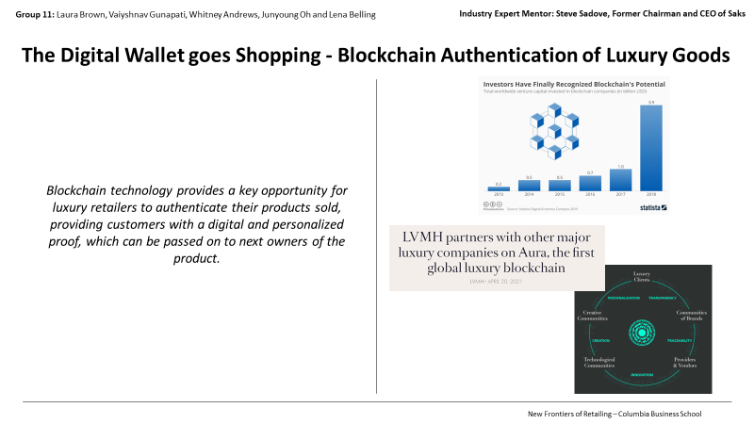

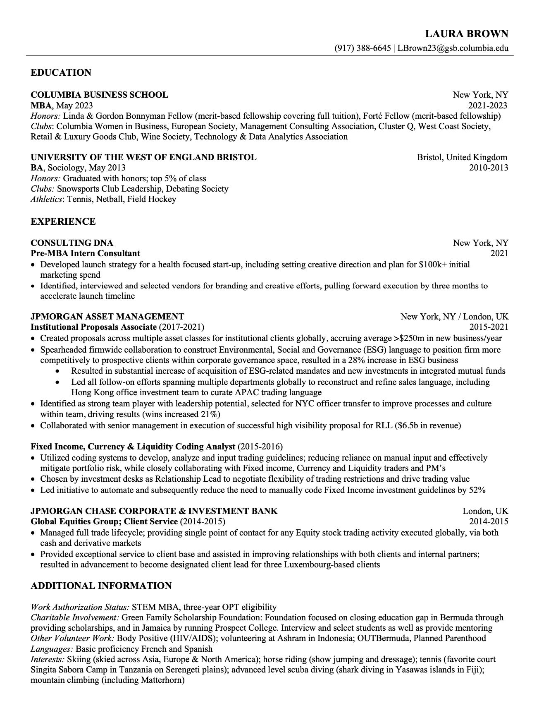

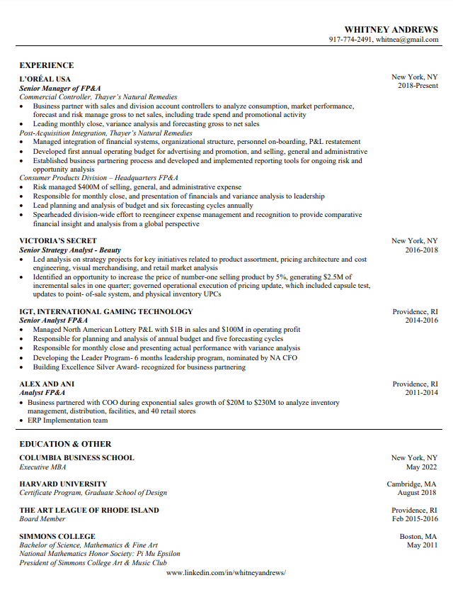

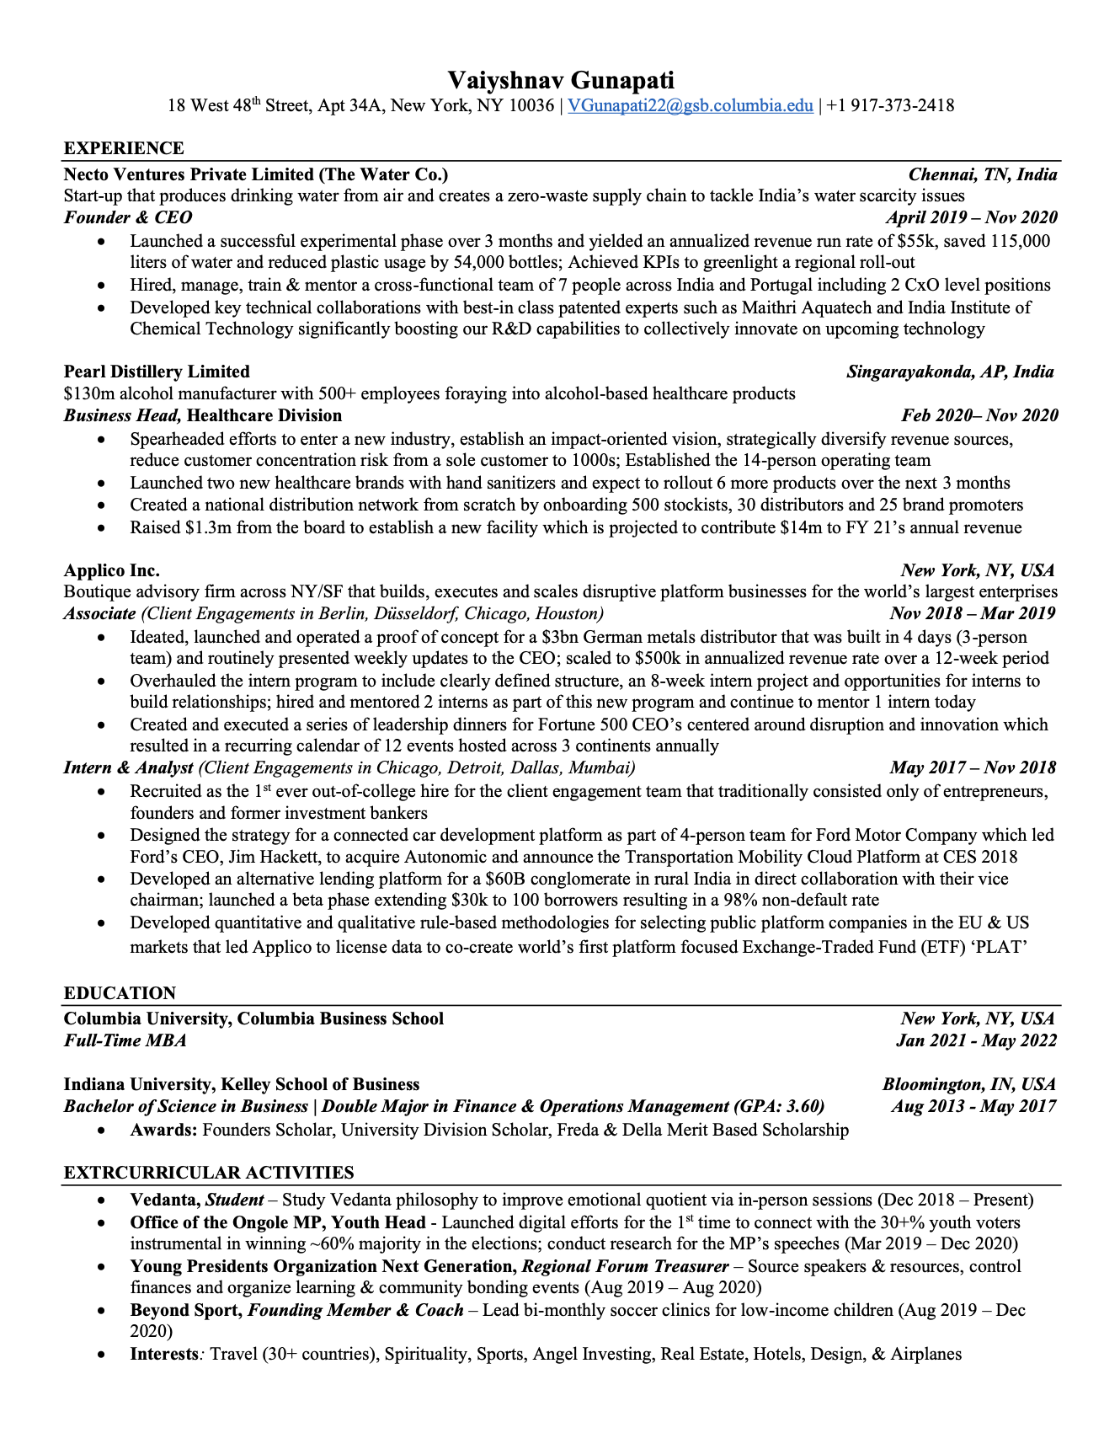

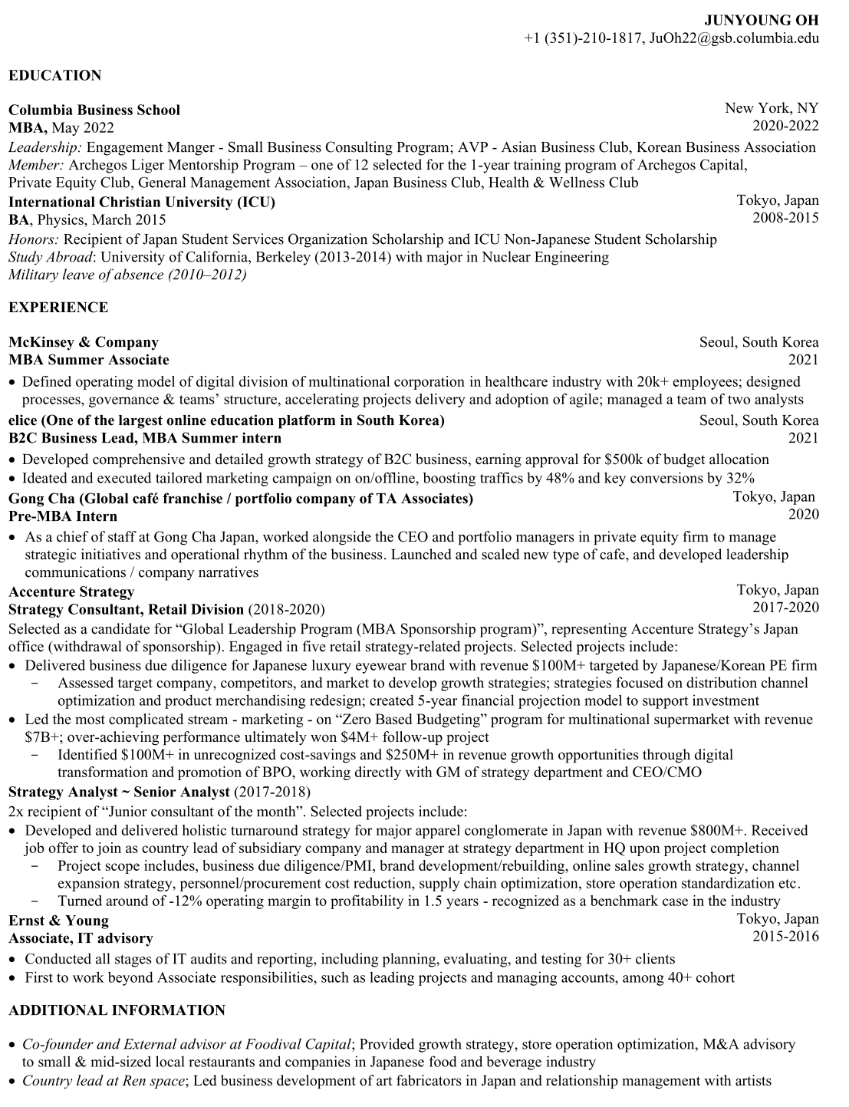

**Bibliography**

* <https://www.thefashionlaw.com/blockchain-and-nfts-are-smart-but-can-they-revolutionize-fashion/>
* <https://hbr.org/2019/05/how-luxury-brands-can-beat-counterfeiters>
* <https://www.therobinreport.com/luxury-brands-try-on-blockchain/#:~:text=A%20New%20Blockchain%20Consortium,Consortium%20to%20address%20this%20issue>.
* <https://auraluxuryblockchain.com/>
* <https://www2.deloitte.com/content/dam/insights/us/articles/6608_2020-global-blockchain-survey/DI_CIR%202020%20global%20blockchain%20survey.pdf>
* <https://www.thredup.com/resale/#size-and-impact>
* <https://www.debeersgroup.com/sustainability-and-ethics/leading-ethical-practices-across-the-industry/tracr>
* <https://everledger.io/industry-solutions/luxury-goods/>
* <https://presslounge.vacheron-constantin.com/vacheron-constantin-certifies-its-entire-range-of-watches-using-blockchain-technology/>

1. The Aura Blockchain Consortium Website
2. Carbon Magazine: Are digital fashion IDs the future? March 2022
3. Deloitte: Digital transformation - the ultimate challenge for the fashion industry. 9 August 2018
4. Net-A-Porter: Porte & Paire Launches Digital ID – A Game-Changing New Shopping Experience: August 5 2021
5. McKinsey: The State of Fashion 2022
6. Morgan Stanley: Luxury in the Metaverse; November 16, 2021
7. Vogue Business: Are NFTs sustainable? Rachel Chernansky; February 24, 2022
8. Glossy: NFTs are the next fashion craze, but their environmental impact looms large; Danny Parisi; May 3 2021